**EX NO: 5**

**PACKET ANALYZER TOOL**

**AIM:**

To Analyse the network packet transmission using packet analyzer tool (Wireshark).

**PROCEDURE:**

1. Capture the packets (TCP / UDP / HTTP)
2. Filter those packets
3. Inspect those packets

**Step 1: Install and open WireShark .**

**Step 2: To capture TCP / UDP /HTTP Packet.**

**Step 3: to Filter TCP / UDP /HTTP Packet.**

**Step4: to inspect the TCP / UDP /HTTP Packet.**

**OUTPUT**

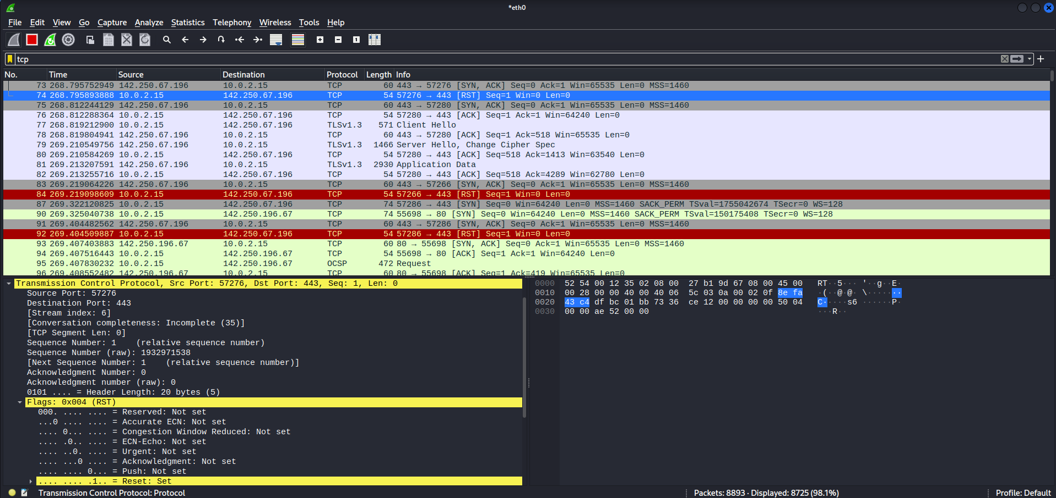

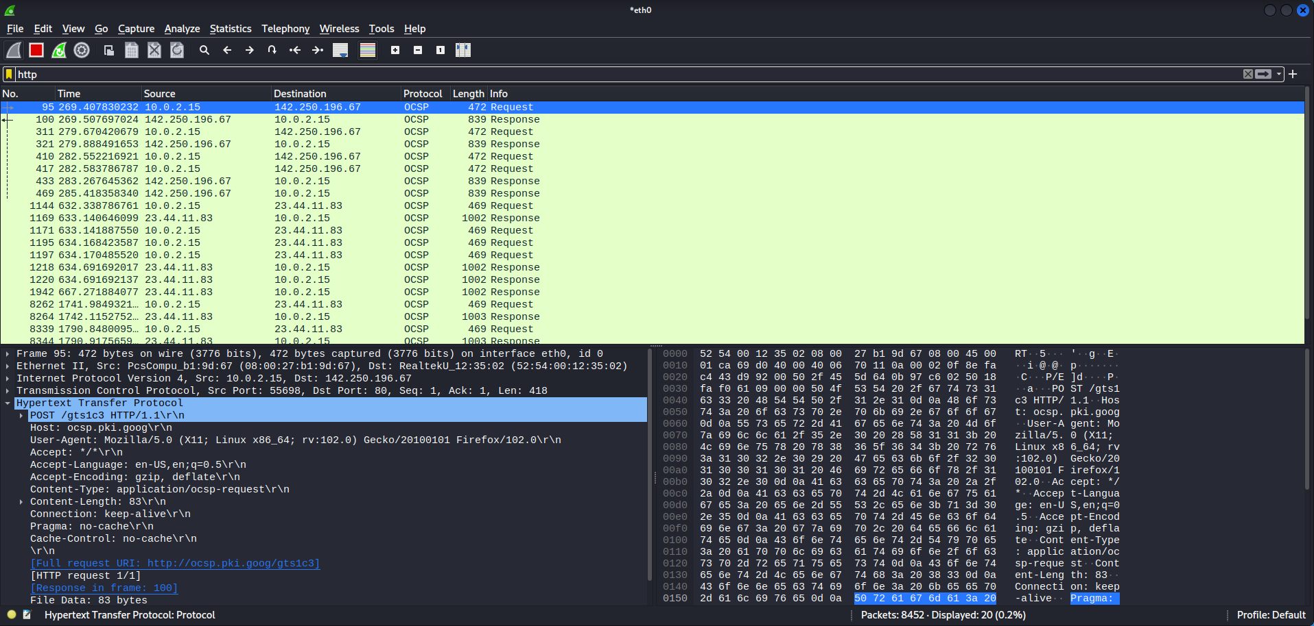

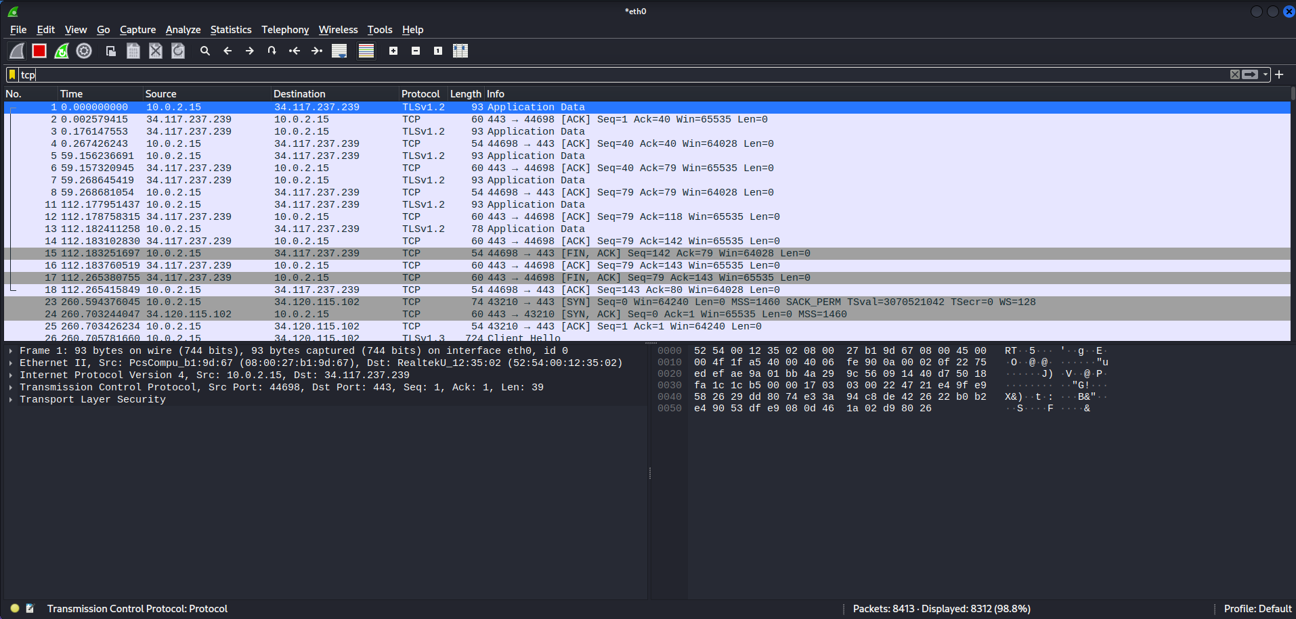

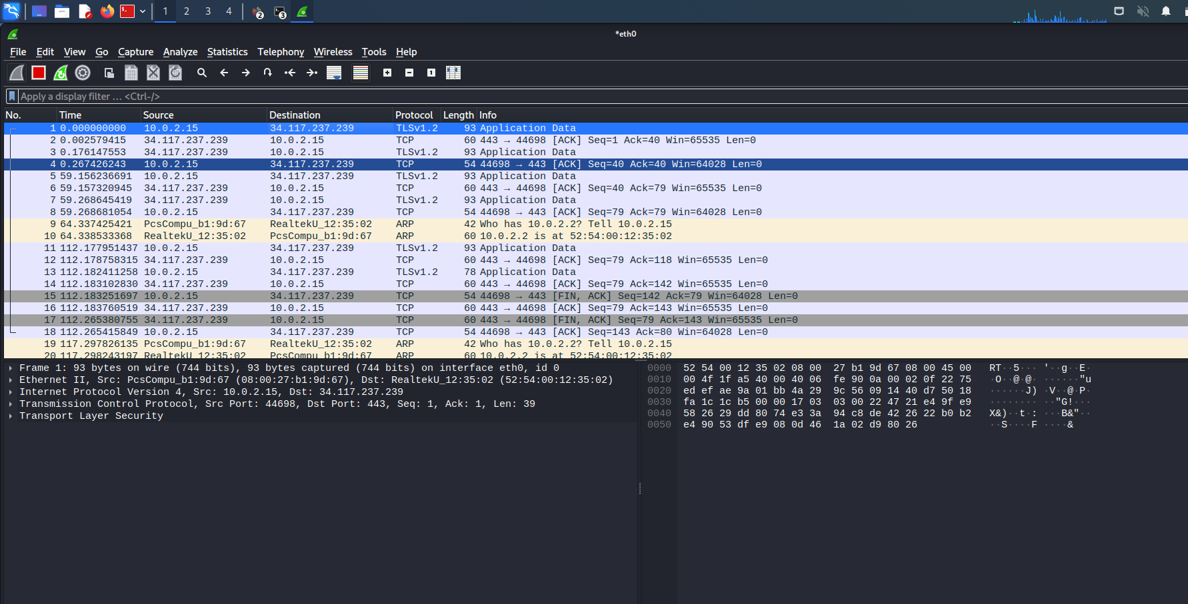

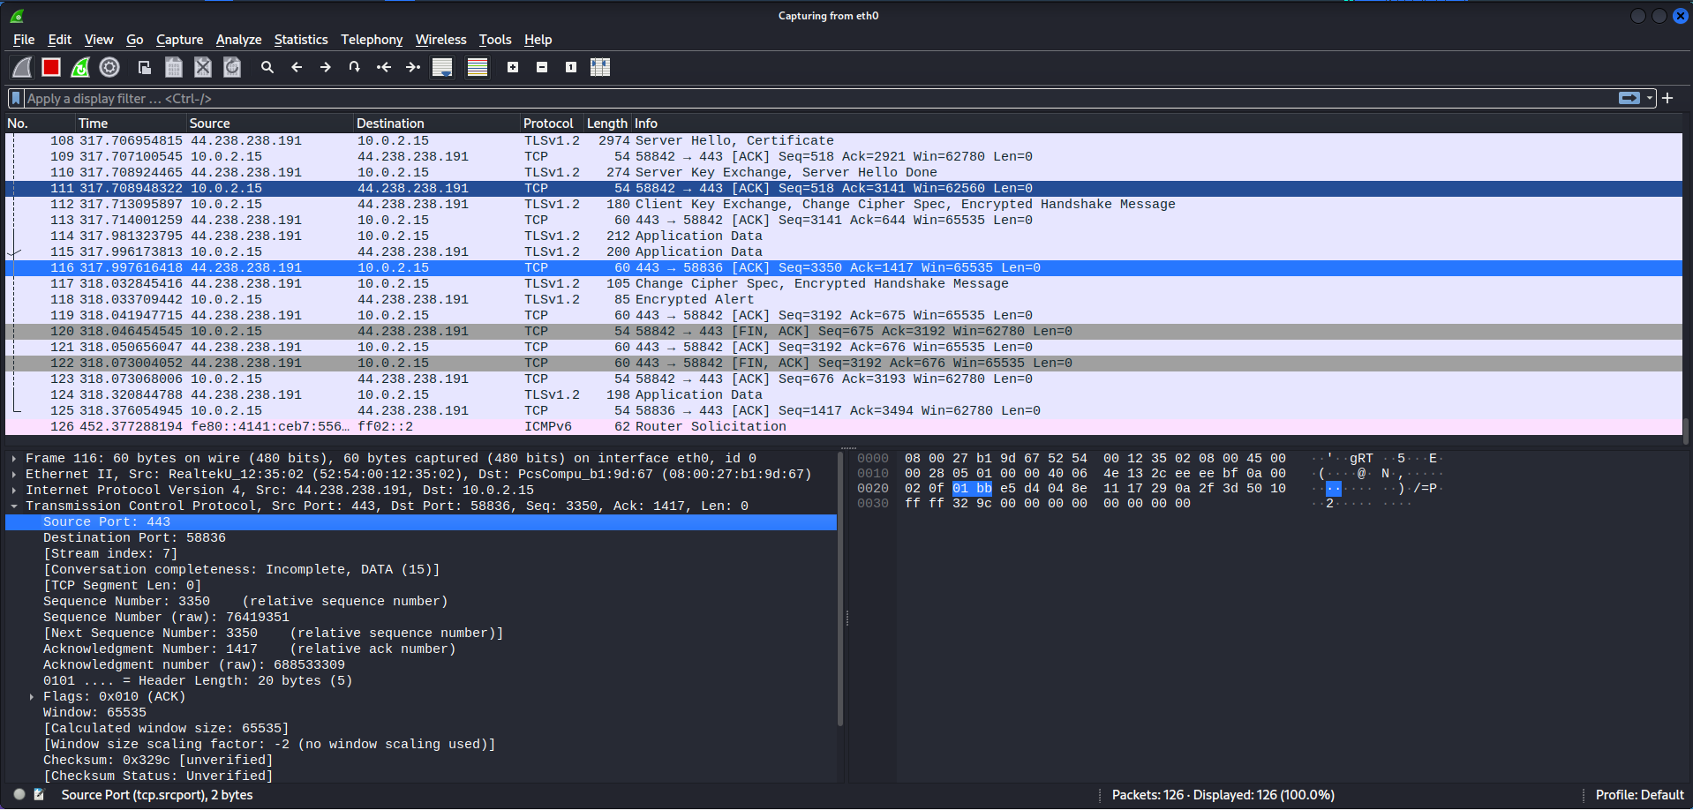

**Result**

Hence the analysing of the network packet transmission using packet analyzer tool (Wireshark) is performed successfully.